Project 13 – Minesweeper

(20 points)

Name: Ozaner Hansha

Description:

In this partner project, you will program the classic Microsoft Windows game, Minesweeper. Here are some requirements:
Phase 1
- Must support multiple rounds
- Must have a grid arrangement.
- Must have a GUI.
- Should have difficulty levels.
- Should support flagging on a right click.
- Should support multiple sizes.
- May have custom settings for bomb density.
- May save the lowest time (best score) per level.

Phase 2
- Must have a timer.

Phase 3
- Must include sound effects (particularly the exploding mine).

The design UML diagram is as follows:
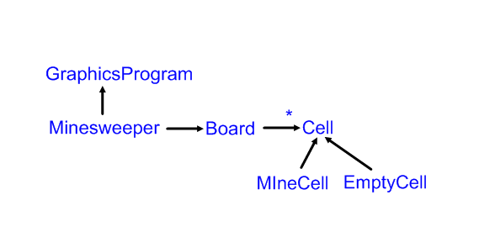
The technology specifications included:
1. Use ACM Library for graphics.
2. Set up to use as either an application or an applet.
The GUI will approximate a Windows version of the game. Here are some images.
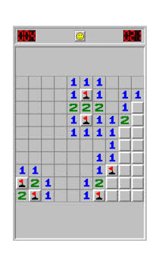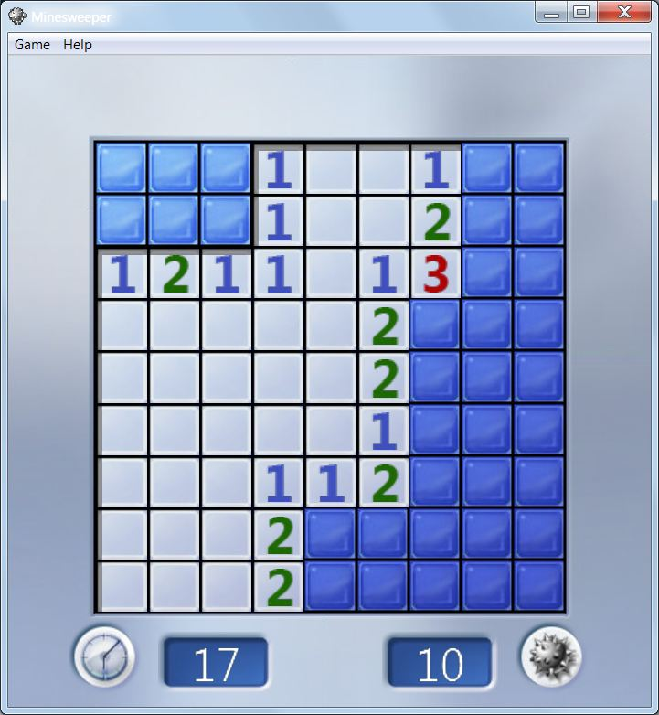
Windows 7 Version Windows XP Version
We will place our code in a package for this project. Use the edu.chatham.games package.
Your project should have five classes – Minesweeper, Board, Cell, EmptyCell and MineCell.
I am giving you outlines of the Minesweeper and Cell classes. Cell is a Java abstract class. Remember that an abstract class is somewhat like a Java interface in that it is non instantiable – i.e., you cannot use the new operator to create an instance of it. It is also like a Java interface in that it can require certain methods to be implemented by declaring them abstract. Unlike an interface, however, it can contain implemented methods, constructors, instance variables, etc. Subclasses can extend the abstract superclass, and an abstract class can be used as a type when declaring variables of its subclasses. The main advantage of an abstract class over an interface is that you can provide a partial implementation
Phases of Completion

- Version 1 is to get the basic game working.
- Version 2 is to add a timer in the GUI that you must play against.
- Version 3 is to add at least one sound effect.

To complete the project, submit each version as a Word document as you have done earlier this year:
- Fill your name out above and add your source listings.
- Show screenshots of your game at various stages of play – start, midgame, win, loss, etc.
Minesweeper.java
package unit11.minesweeper;

import java.awt.Dimension;
import java.awt.event.ActionEvent;
import java.awt.event.ActionListener;
import java.io.File;

import javax.swing.ButtonGroup;
import javax.swing.JButton;
import javax.swing.JLabel;
import javax.swing.JOptionPane;
import javax.swing.JRadioButton;
import javax.swing.JTextField;
import javax.swing.Timer;

import acm.program.GraphicsProgram;
import acm.util.SoundClip;

/**
* Minesweeper made using Java components.
* @author Ozaner Hansha
*/
@SuppressWarnings("serial")
public class Minesweeper extends GraphicsProgram {
/**
* Runs Minesweeper as an application.
* @param args none are expected
*/
public static void main(String[] args) {
(new Minesweeper()).start(args);
}

//Difficulty Constants
private static final Dimension EASY_DIM = new Dimension(8,8);
private static final Dimension NORMAL_DIM = new Dimension(16,16);
private static final Dimension HARD_DIM = new Dimension(16,31);

private static final int MIN_DIM = 2;
private static final int MAX_ROWS = 20;
private static final int MAX_COLS = 31;

private static final int EASY_MINES = 10;
private static final int NORMAL_MINES = 40;
private static final int HARD_MINES = 99;

//Difficulty Variables
private int currentRows = (int)EASY_DIM.getWidth();
private int currentCols = (int)EASY_DIM.getHeight();
private int currentMines = (int)EASY_MINES;

/**
* Sound clip of a mine exploding.
*/
public static final SoundClip BOMB_SOUND = new SoundClip(new File("minesweeperRes/bomb.wav"));

/**
* Location to load/save scores.
*/
public static final String SCORE_LOCATION = "minesweeperRes/scores.xml";

/**
* Amount to offset the width on account of the GUI
*/
private static final int WIDTH_OFFSET = 121;

/**
* Amount to offset the height on account of the GUI
*/
private static final int HEIGHT_OFFSET = 62;

/**
* A Board of cells.
*/
private Board board;

/**
* Thread that keep track of the timer.
*/
private Timer timer;

/**
* current time taken on the board in seconds.
*/
private int currentTime;

/**
* Amount of wins and losses.
*/
private int wins, losses;

/**
* Record of highscores.
*/
private ScoreSheet scoreSheet = new ScoreSheet();

/**
* Whether the game is over or not.
*/
private boolean gameOver;

//GUI Fields
private JRadioButton[] difficulties = {new JRadioButton("Easy"),
new JRadioButton("Normal"),new JRadioButton("Hard"), new JRadioButton("Custom")
};
private ButtonGroup difficultyGroup = new ButtonGroup();
private JLabel winsTag = new JLabel("Wins: 0"),
lossesTag = new JLabel("Losses: 0"),
timerLabel = new JLabel("Time Taken: 0");
private JButton newGame = new JButton("New Game");
private JTextField customRows = new JTextField("Rows"),
customCols = new JTextField("Columns"),
customMines = new JTextField("Mines");

/**
* Create a Minesweeper game.
*/
public Minesweeper(){}

/**
* Initializes the board, which is also the GUI.
*/
public void init() {
BOMB_SOUND.setVolume(.5);
scoreSheet.loadXML(SCORE_LOCATION);

timer = new Timer(1000,new ActionListener() {
@Override
public void actionPerformed(ActionEvent e) {
currentTime++;
timerLabel.setText("Time Taken: " + currentTime);
}
});
timer.start();

//Difficulty options
for(JRadioButton b: difficulties) {
difficultyGroup.add(b);
add(b,WEST);
b.addActionListener(this);
}
difficulties[0].setSelected(true);

//New Game button
add(newGame,WEST);
newGame.addActionListener(this);

//Custom difficulty boxes
add(customRows,WEST);
customRows.addActionListener(this);
customRows.setEnabled(false);

add(customCols,WEST);
customCols.addActionListener(this);
customCols.setEnabled(false);

add(customMines,WEST);
customMines.addActionListener(this);
customMines.setEnabled(false);
updateGUI();

add(winsTag,WEST);
add(lossesTag,WEST);
add(timerLabel,WEST);

reset();
addActionListeners();
}

/**
* Resets the board with the current difficulty variables.
*/
public void reset() {
gameOver = false;
if(difficulties[3].isSelected()) {
currentRows = Integer.parseInt(customRows.getText());
currentCols = Integer.parseInt(customCols.getText());
currentMines = Integer.parseInt(customMines.getText());
}

//Check if board size is within bounds.
if(currentRows < MIN_DIM)
currentRows = MIN_DIM;
if(currentRows > MAX_ROWS)
currentRows = MAX_ROWS;
if(currentCols < MIN_DIM)
currentCols = MIN_DIM;
if(currentCols > MAX_COLS)
currentCols = MAX_COLS;
if(currentMines > currentRows*currentCols)
currentRows = currentRows*currentCols-1;
updateGUI();

removeAll(); //removes old board
board = new Board(currentRows,currentCols,currentMines); //create new board

//Add Cells to Canvas
for(int r = 0; r < board.getRows(); r++)
for(int c = 0; c < board.getCols(); c++) {
add(board.getCellAt(r, c),c*Cell.CELL_HEIGHT,r*Cell.CELL_WIDTH);
board.getCellAt(r, c).addActionListener(this);
}

//Set Size
setSize(board.getCols()*Cell.CELL_WIDTH+WIDTH_OFFSET, board.getRows()*Cell.CELL_HEIGHT+HEIGHT_OFFSET);

currentTime = 0;
timerLabel.setText("Time Taken: 0");
timer.start();
}

/**
* Handler for button and cell actions.
*/
@Override
public void actionPerformed(ActionEvent e) {
if(e.getActionCommand() == "New Game") {
reset();
}
else if(e.getActionCommand() == "Easy") {
currentRows = (int)EASY_DIM.getWidth();
currentCols = (int)EASY_DIM.getHeight();
currentMines = (int)EASY_MINES;
enableTextBoxes(false);
updateGUI();
}
else if(e.getActionCommand() == "Normal") {
currentRows = (int)NORMAL_DIM.getWidth();
currentCols = (int)NORMAL_DIM.getHeight();
currentMines = (int)NORMAL_MINES;
enableTextBoxes(false);
updateGUI();
}
else if(e.getActionCommand() == "Hard") {
currentRows = (int)HARD_DIM.getWidth();
currentCols = (int)HARD_DIM.getHeight();
currentMines = (int)HARD_MINES;
enableTextBoxes(false);
updateGUI();
}
else if(e.getActionCommand() == "Custom") {
enableTextBoxes(true);
updateGUI();
}
else if(e.getSource() instanceof Cell && !gameOver) {
Cell cell = (Cell) e.getSource();
int result = board.clickCell(cell);

String title = "",message = "";
Object[] options = {"Continue", "Exit"};
int choice = 0;

switch(result) {
case 1: //Game won
timer.stop();
wins++;
updateGUI();
gameOver = true;
title = "You Win!";

int previousTime = scoreSheet.getScore(board.getRows(), board.getCols());
scoreSheet.addScore(board.getRows(), board.getCols(), board.getMines(), currentTime);

if(previousTime == -1)
message = "You Win! Your time was " + currentTime + "s";
else if(previousTime > currentTime)
message = "You beat the previous high time of " + previousTime
+ "s with a score of " + currentTime + "s!";
else
message = "You Win! Your time was " + currentTime +
"s. The record for this config is " + previousTime;
break;
case 2: //Game lost
BOMB_SOUND.play();
timer.stop();
losses++;
updateGUI();
gameOver = true;
title = "You Lose!";
message = "You Lost! Your time was " + currentTime + "s.";
break;
default: //Continue game if not won or lost.
return;
}
choice = JOptionPane.showOptionDialog(this, message, title,
JOptionPane.DEFAULT_OPTION, JOptionPane.INFORMATION_MESSAGE,
null, options, options[0]);
if(choice == 1) {
scoreSheet.saveXML(SCORE_LOCATION); //Saves scores before exiting.
System.exit(0);
}
}
}

/**
* Updates the text boxes with the current row/col/mines and the scores.
*/
public void updateGUI() {
customRows.setText(""+currentRows);
customCols.setText(""+currentCols);
customMines.setText(""+currentMines);
lossesTag.setText("Losses: "+ losses);
winsTag.setText("Wins: "+ wins);
}

/**
* Enables or disables all textboxes
* @param lock
*/
public void enableTextBoxes(boolean lock) {
customRows.setEnabled(lock);
customCols.setEnabled(lock);
customMines.setEnabled(lock);
}
}
Cell.java
package unit11.minesweeper;

import java.awt.Color;
import java.awt.Image;
import java.awt.event.MouseAdapter;
import java.awt.event.MouseEvent;
import javax.swing.ImageIcon;
import javax.swing.JButton;

/**
* Abstract class representing a Minesweeper Cell.
* @author Ozaner Hansha
*/

@SuppressWarnings("serial")
public abstract class Cell extends JButton {

public static final int CELL_WIDTH = 40;
public static final int CELL_HEIGHT = 40;

protected int row, col;
protected boolean revealed;
protected boolean marked;

private static ImageIcon FLAG;

/**
* Creates a Minesweeper Cell given a row and a column.
* The default unrevealed cell is currently a simple blue rectangle.
* @param r
* @param c
*/
public Cell(int r, int c) {
super("");
setSize(CELL_WIDTH,CELL_HEIGHT);
setBackground(Color.BLUE);
Image flag = new ImageIcon("minesweeperRes/flag.png").getImage();
FLAG = new ImageIcon(flag.getScaledInstance(Cell.CELL_WIDTH, Cell.CELL_HEIGHT, 0));
row = r;
col = c;
revealed = false;
Cell cell = this;
addMouseListener(new MouseAdapter(){
public void mouseClicked(MouseEvent e){
if(e.isMetaDown() && !cell.isRevealed())
cell.mark();
}
});
}

/**
* @param board - Board this cell is contained in.
* @return Amount of mines within 1 square of this cell.
*/
public int getMineCount(Board board) {
int count = 0;
for(int x = -1; x < 2; x++)
for(int y = -1; y < 2; y++)
if(board.getCellAt(row+x, col+y) instanceof MineCell)
count++;
return count;
}

/**
* Any subclass of Cell must implement this method to change the
* appearance and state of the cell to reflect its being revealed.
*/
public abstract void reveal(Board board, boolean firstMine);

/**
* Test if the cell has been revealed.
* @return true if the cell has been revealed, false otherwise
*/
public boolean isRevealed() {
return revealed;
}

/**
* @param cell1
* @param cell2
* @return Whether the 2 cells are adjacent.
*/
public boolean isAdjacent(Cell cell) {
return (getRow() == cell.getRow() && Math.abs(getCol() - cell.getCol()) == 1) ||
(getCol() == cell.getCol() && Math.abs(getRow() - cell.getRow()) == 1);
}

public boolean isMarked() {
return marked;
}

/**
* Getter for the cell's row.
* @return the row
*/
public int getRow() {
return row;
}

/**
* Getter for the cell's column
* @return the column
*/
public int getCol() {
return col;
}

public void mark() {
if(marked) {
setIcon(null);
marked = false;
}
else {
setIcon(FLAG);
marked = true;
}
}

/**
* A printable representation of a Cell.
*/
public String toString() {
return String.format("[%d,%d]", row, col);
}
}
BlankCell.java
package unit11.minesweeper;

import java.awt.Color;
import java.awt.Font;

/**
* Class extending {@link Cell} but without a mine.
* @author Ozaner Hansha
*/
@SuppressWarnings("serial")
public class BlankCell extends Cell {

/**
* @param r - row
* @param c - column
*/
public BlankCell(int r, int c) {
super(r, c);
}

/**
* Reveals the cell by turning it gray and displaying
* the amount of mines present, unless it is 0.
* @see unit11.minesweeper.Cell#reveal()
*/
@Override
public void reveal(Board board, boolean firstMine) {
setBackground(Color.GRAY);
this.setFont(new Font("Times New Roman", 0, 13));
if(getMineCount(board) > 0)
setText(""+getMineCount(board));
setIcon(null);
revealed = true;
}
}
MineCell.java
package unit11.minesweeper;

import java.awt.Color;
import java.awt.Image;
import javax.swing.ImageIcon;

/**
* Class extending {@link Cell} but with a mine.
* @author Ozaner Hansha
*/
@SuppressWarnings("serial")
public class MineCell extends Cell {

private static ImageIcon mineRed;
private static ImageIcon mineGray;
static {
loadImage();
}

/**
* @param r
* @param c
*/
public MineCell(int r, int c) {
super(r, c);
}

public static void loadImage() {
Image temp = new ImageIcon("minesweeperRes/Mine_Red.png").getImage();
mineRed = new ImageIcon(temp.getScaledInstance(Cell.CELL_WIDTH, Cell.CELL_HEIGHT, 0));
temp = new ImageIcon("minesweeperRes/Mine_Gray.png").getImage();
mineGray = new ImageIcon(temp.getScaledInstance(Cell.CELL_WIDTH, Cell.CELL_HEIGHT, 0));
}

/**
* @see unit11.minesweeper.Cell#reveal()
*/
@Override
public void reveal(Board board, boolean firstMine) {
setBackground(Color.RED);
if(!isRevealed())
if(firstMine)
setIcon(mineRed);
else
setIcon(mineGray);
revealed = true;
}
}
Board.java
package unit11.minesweeper;

import java.awt.Point;
import java.util.HashSet;
import java.util.Set;

/**
* Represents a Minesweeper Board. Made for us with {@link Cell}s.
* @author Ozaner Hansha
*/
public class Board {

/**
* The 2D Array holding all the {@link Cell}s
*/
private Cell[][] board;

/**
* amount of mines on this board.
*/
private int amountOfMines;

/**
* Creates a new board with the given amounts of rows, columns, and mines.
* @param r - rows
* @param c - columns
* @param amountOfMines - amount of random mines put on board
*/
public Board(int r, int c, int amountOfMines) {
this.amountOfMines = amountOfMines;
board = new Cell[r][c];
populateBoard(); //Populate board with cells
}

/**
* Randomly* Fills the board with the {@link #amountOfMines}
* specified in the constructor.
* @param r - rows
* @param c - columns
*/
private void populateBoard() {
Set<Point> mineLocations = new HashSet<Point>();
while(mineLocations.size() != amountOfMines) {
int x = (int)(Math.random()*getRows());
int y = (int)(Math.random()*getCols());
mineLocations.add(new Point(x,y));
}
for(int x = 0; x < getRows(); x++)
for(int y = 0; y < getCols(); y++)
if(mineLocations.contains(new Point(x,y)))
board[x][y] = new MineCell(x,y);
else
board[x][y] = new BlankCell(x,y);
}

/**
* @return rows of the board.
*/
public int getRows() {
return board.length;
}

/**
* @return columns of the board.
*/
public int getCols() {
return board[0].length;
}

/**
* @return amount of mines on the board.
*/
public int getMines() {
return amountOfMines;
}

/**
* @param row
* @param col
* @return The cell at the row & column, null if invalid row and column.
*/
public Cell getCellAt(int row, int col) {
if(row < getRows() && row >= 0 && col < getCols() && col >= 0)
return board[row][col];
return null;
}

/**
* Reveals the given cell if it is in this board.
* @param cell
*/
public void reveal(Cell cell, boolean firstMine) {
getCellAt(cell.getRow(),cell.getCol()).reveal(this, firstMine);
}

/**
* @return Whether or not all blanks on the board have been revealed.
*/
public boolean allBlanksRevealed() {
for(int x = 0; x < getRows(); x++)
for(int y = 0; y < getCols(); y++)
if(getCellAt(x,y) instanceof BlankCell && !getCellAt(x,y).isRevealed())
return false;
return true;
}

/**
* Reveals all blanks in an area contained within mines or the edge.
* @param cell
*/
public void revealBlanks(Cell cell) {
if(cell.getMineCount(this) == 0) {
revealBlanksHelper(getCellAt(cell.getRow()-1, cell.getCol()-1));
revealBlanksHelper(getCellAt(cell.getRow()-1, cell.getCol()));
revealBlanksHelper(getCellAt(cell.getRow()-1, cell.getCol()+1));

revealBlanksHelper(getCellAt(cell.getRow(), cell.getCol()-1));
revealBlanksHelper(getCellAt(cell.getRow(), cell.getCol()+1));

revealBlanksHelper(getCellAt(cell.getRow()+1, cell.getCol()-1));
revealBlanksHelper(getCellAt(cell.getRow()+1, cell.getCol()));
revealBlanksHelper(getCellAt(cell.getRow()+1, cell.getCol()+1));
}
}

/**
* Helps the {@link #revealBlanks(Cell)} method with recursion.
* @param cell
*/
public void revealBlanksHelper(Cell cell) {
if(cell == null || cell.isRevealed()) //Nonexistent|already revealed.
return;
else if(cell instanceof BlankCell) {
if(cell.getMineCount(this) == 0) { //Non-edge blank cell (mines=0)
cell.reveal(this, false);
revealBlanks(cell);
}
else //Edge blank cell (mines>0)
cell.reveal(this, false);
}
}

/**
* @param cell
* @return 0 if game continued, 1 if game won, 2 if game lost.
*/
public int clickCell(Cell cell) {
if(!cell.isMarked()) {
reveal(cell,true);
if(cell instanceof MineCell) {
revealAll();
return 2; //Game Lost
}
else if(cell instanceof BlankCell) {
revealBlanks(cell);
if(allBlanksRevealed()) {
revealAll();
return 1; //Game Won
}
return 0; //Cell revealed.
}
}
return 0; //Cell already revealed.
}

/**
* Reveals all cells in the board.
*/
public void revealAll() {
for(int x = 0; x < getRows(); x++)
for(int y = 0; y < getCols(); y++)
reveal(getCellAt(x,y),false);
}
}
ScoreSheet.java
package unit11.minesweeper;

import java.io.File;
import java.util.ArrayList;
import java.util.List;
import javax.xml.bind.JAXBContext;
import javax.xml.bind.JAXBException;
import javax.xml.bind.Marshaller;
import javax.xml.bind.Unmarshaller;
import javax.xml.bind.annotation.XmlAccessType;
import javax.xml.bind.annotation.XmlAccessorType;
import javax.xml.bind.annotation.XmlElement;
import javax.xml.bind.annotation.XmlRootElement;
import javax.xml.bind.annotation.XmlType;

/**
* Saves/Reads Minesweeper scores in an XML format.
* @author Ozaner Hansha
*/
@XmlRootElement(name = "scores")
@XmlAccessorType(XmlAccessType.FIELD)
public class ScoreSheet {

@XmlElement(name = "score")
private List<Score> scores = new ArrayList<Score>();

public ScoreSheet(){}

/**
* Saves the current state of the scoresheet in an xml file.
* @param location
*/
public void saveXML(String location) {
try {
File file = new File(location);
JAXBContext context = JAXBContext.newInstance(ScoreSheet.class);
Marshaller writer = context.createMarshaller();

writer.setProperty(Marshaller.JAXB_FORMATTED_OUTPUT, true);
writer.marshal(this, file);
}
catch (JAXBException e) {
e.printStackTrace();
}
}

/**
* Loads and overrides the current state of the sheet with one form an xml file.
* @param location
*/
public void loadXML(String location) {
try {
File file = new File(location);
JAXBContext context = JAXBContext.newInstance(ScoreSheet.class);
Unmarshaller reader = context.createUnmarshaller();

ScoreSheet s = (ScoreSheet)reader.unmarshal(file);
scores = s.getScores();
}
catch (JAXBException e) {}
}

private List<Score> getScores() {
return scores;
}

/**
* Adds a score to the list of it beats a record.
* @param row - rows of the board.
* @param col - columns of the board.
* @param time - time taken.
*/
public void addScore(int row, int col, int mine, int time) {
if(col > row) {
int temp = col;
col = row;
row = temp;
}
if(getScore(row,col) == -1)
scores.add(new Score(row,col,mine,time));
else if(getScore(row,col) > time) {
for(Score s: scores) {
if(s.getRow() == row && s.getCol() == col) {
s.setTime(time);
}
}
}
}

/**
* @param row - rows of board
* @param col - columns of board
* @return time took to finish board. -1 if no score present.
*/
public int getScore(int row, int col) {
if(col > row) {
int temp = col;
col = row;
row = temp;
}
for(Score s: scores) {
if(s.getRow() == row && s.getCol() == col) {
return s.getTime();
}
}
return -1;
}

/**
* A class representing a score for a certain minesweeper config.
* @author Ozaner Hansha
*/
@XmlType
static class Score {
int row;
int col;
int mines;
int time;

public Score() {}

public Score(int row, int col, int mines, int time) {
//Makes row the biggest number (so 5x6 score = 6x5 score)
if(col > row) {
int temp = col;
col = row;
row = temp;
}
this.row = row;
this.col = col;
this.mines = mines;
this.time = time;
}

@XmlElement
public void setRow(int row){
this.row = row;
}

public int getRow(){
return row;
}

@XmlElement
public void setCol(int col){
this.col = col;
}

public int getCol(){
return col;
}

@XmlElement
public void setMines(int mines){
this.mines = mines;
}

public int getMines(){
return mines;
}

@XmlElement
public void setTime(int time){
this.time = time;
}

public int getTime(){
return time;
}
}
}
Screenshots
